ASSINGMENT – 26

CODE:

IN

CREATE OR REPLACE PROCEDURE raise_salary

(employee_id IN emp2.employee_id%TYPE,

p_percent IN NUMBER)

IS

BEGIN

UPDATE emp2

SET salary = salary * (1 + p_percent/100)

WHERE employee_id = employee_id;

END raise_salary;

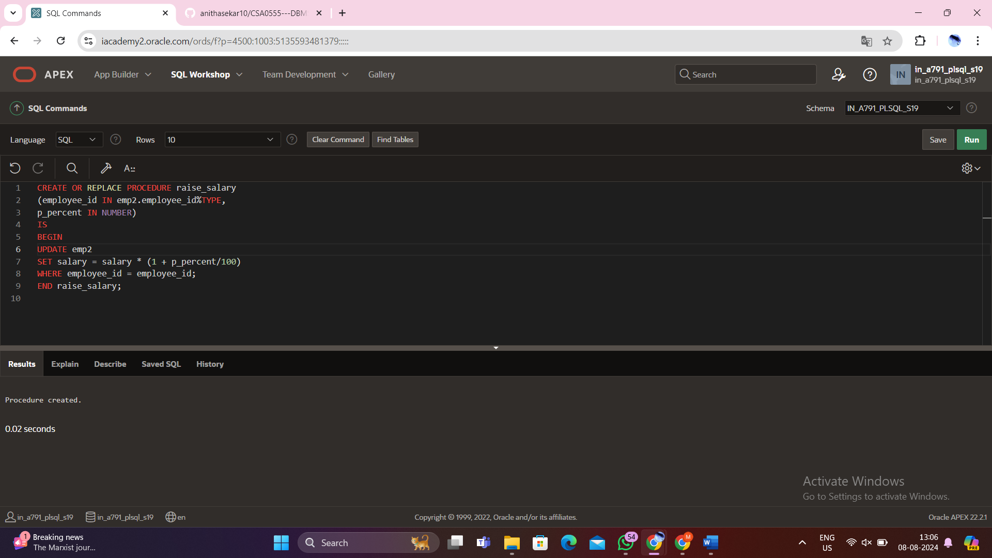

begin

raise_salary(111,10);

End;

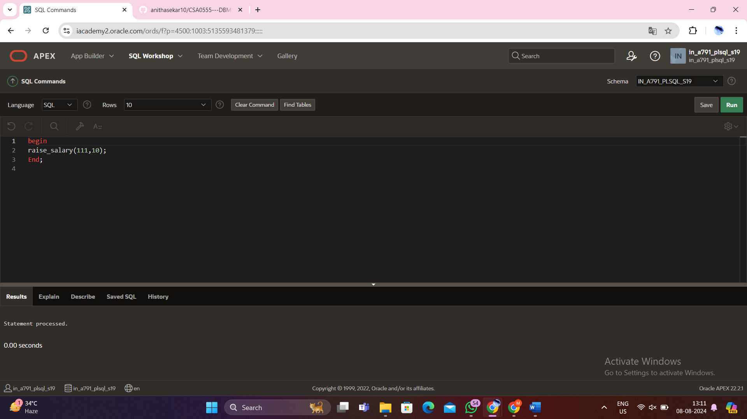

Output:

Select * from emp2;

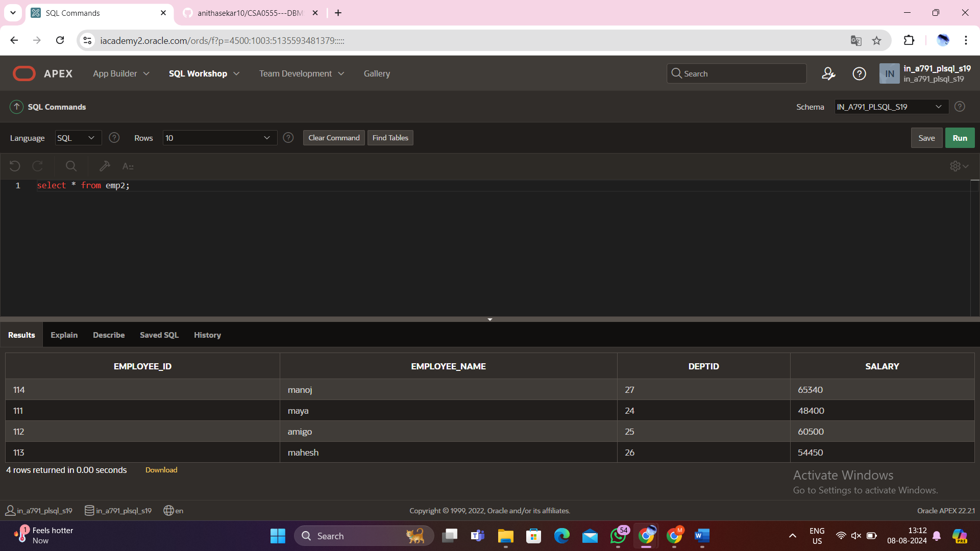

OUT:

CREATE OR REPLACE PROCEDURE query_emp

(p_id IN emp2.employee_id%TYPE,

p_name OUT emp2.employee_name%TYPE,

p_salary OUT emp2.salary%TYPE) IS

BEGIN

SELECT employee_name, salary INTO p_name, p_salary

FROM emp2

WHERE employee_id = p_id;

END query_emp;

DECLARE

a_emp_name emp2.employee_name%TYPE;

a_emp_sal emp2.salary%TYPE;

BEGIN

query_emp(111, a_emp_name, a_emp_sal);

DBMS_OUTPUT.PUT_LINE('Name: ' || a_emp_name);

DBMS_OUTPUT.PUT_LINE('Salary: ' || a_emp_sal);

END;

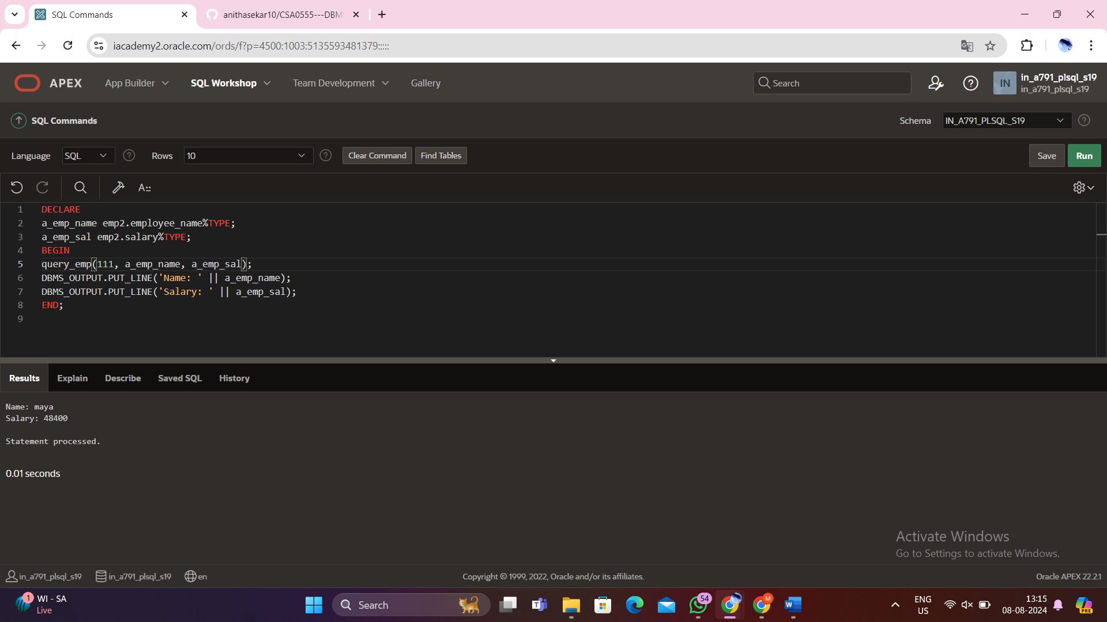

InOut:

CREATE OR REPLACE PROCEDURE update_employee_salary (

p_emp_id IN emp2.employee_id%TYPE,

p_new_salary IN OUT emp2.salary%TYPE

) IS

BEGIN

UPDATE emp2

SET salary = p_new_salary

WHERE employee_id = p_emp_id;

SELECT salary INTO p_new_salary

FROM emp2

WHERE employee_id = p_emp_id;

COMMIT;

END update_employee_salary;

/

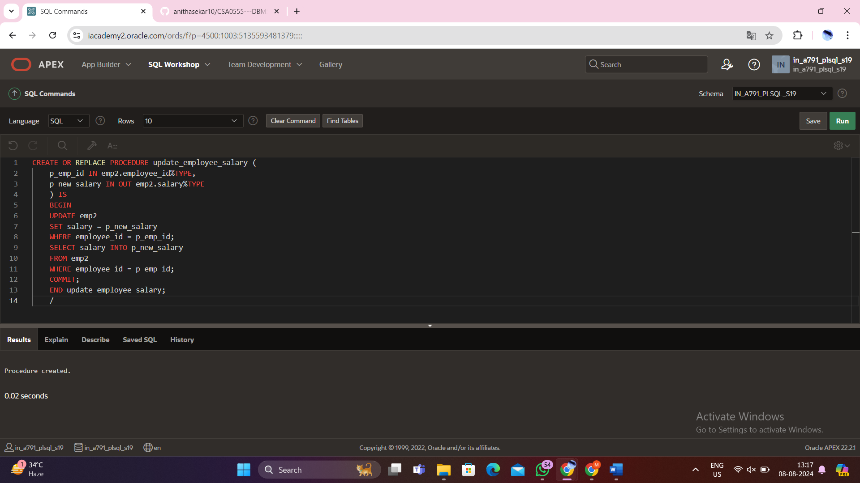

DECLARE

l_emp_id employeees.employee_id%TYPE := 270;

l_new_salary employeees.salary%TYPE := 110000;

BEGIN

update_employee_salary(l_emp_id, l_new_salary);

DBMS_OUTPUT.PUT_LINE('Updated Salary: ' || l_new_salary);

END;

/

